**IAM ROLE**

**INSTANCE:**

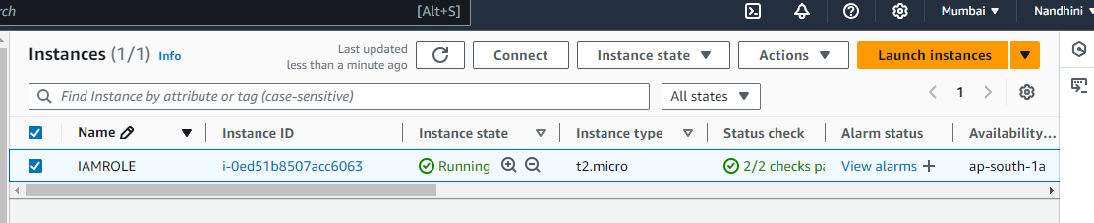

**S3 BUCKET CREATED AND UPLOADED FILE:**

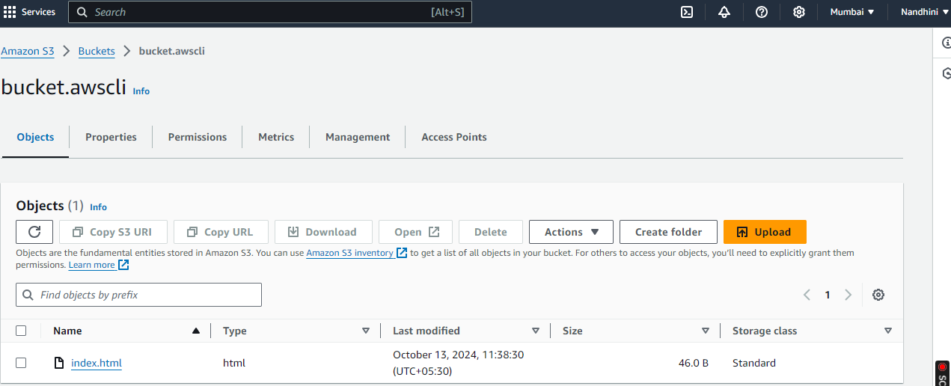

**ROLE CREATED:**

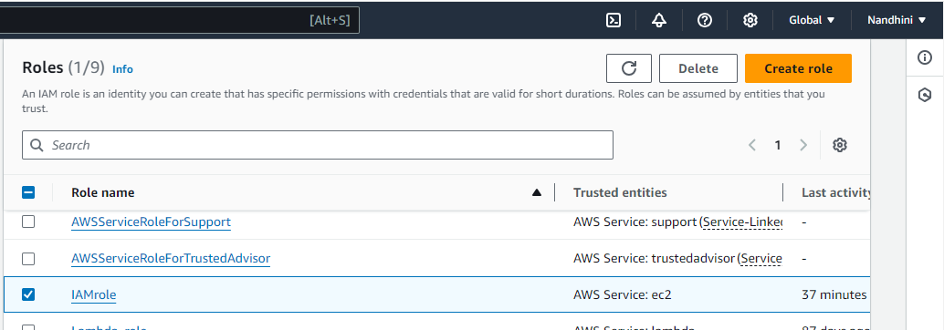

**ROLE ATTACHED TO INSTANCE:**

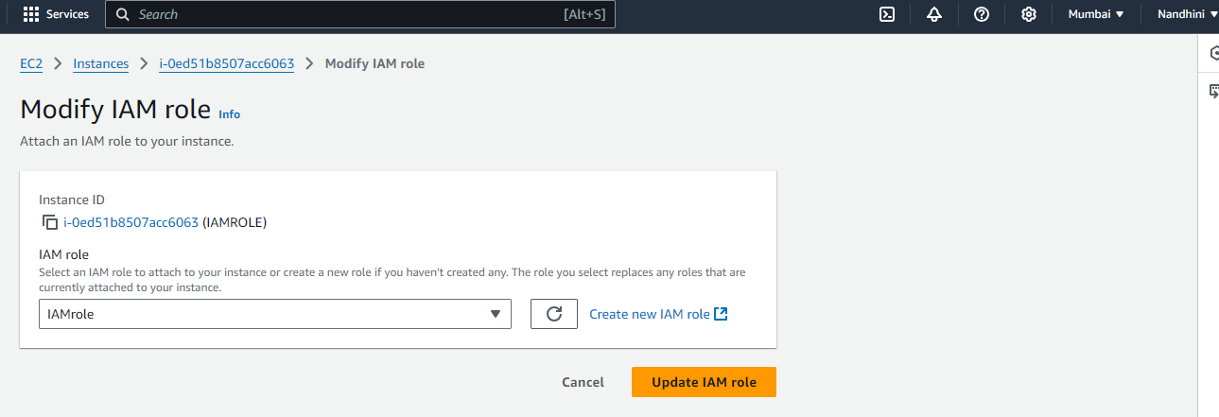

**ACCESSED EC2 and S3:**

